*Florida International University*

*School of Computing and Information Sciences*

Software Engineering Focus

Feature Document

User Story #122

# Set up an admin login page

**Name:** Mariana Sebastian

**Team Member(s):**Nathelly Perez

**Project:** Driverless Car Website 1.0

**Product Owner(s)**: Kianoosh Gholami

**Mentor(s)**: Mohsen Taheri

**Instructor**: Masoud Sadjadi

**User Story Name: Set up an admin login page**

1. Description: **As a**n admin, I want to login to the website so that I can add or/and edit the blogs to my website.

Acceptance Criteria

* User should be provided with the login form with appropriate input fields labeled.
* User must be existed in the database.
* An error message should display as when the user enters the invalid data.

**Use Case #122**

1. Name: Set up an admin login page.
2. Actor: Admin of the website
3. Preconditions: Connected to <http://localhost:4000>
4. Description <Flow of events>:
5. Click blog menu on the navigation bar.
6. Click add blog post button on the page.

**Use Case Diagram <**you can use draw.io**>**

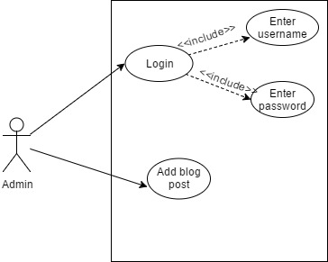

**Sequence Diagram:**

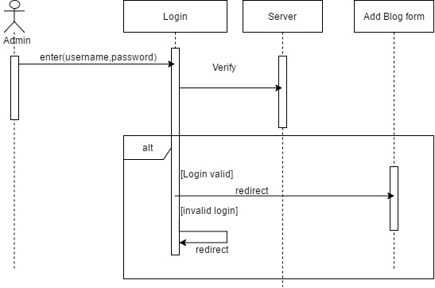

**Class Diagram: N/A**

**Unit Test:**

**Test case 1(Sunny Day)**

* Test case ID:Login_001
* Description/Summary of Test: To test if admin can login with correct credentials.
* Precondition:1. The server is running on the localhost port 4000.

2.Admin click blog menu tab.

3. Admin click add post button

4.Admin enters:

Username: admin

Password: 1234

* Expected Results: Admin gets logged in and redirect to the add post form.
* Actual Result: Admin gets logged in and redirect to the add post form.
* Status (Fail/Pass): PASSED

**Test case 2(Rainy Day)**

* Test case ID:Login_002
* Description/Summary of Test: To test if admin can’t login with incorrect credentials.
* Precondition:1. The server is running on the localhost port 4000.

2.Admin click blog menu tab.

3. Admin click add post button

4.Admin enters:

Username: admin

Password: kkkk

* Expected Results: Admin won’t redirect to the add blog post form.
* Actual Result: Admin won’t redirect to the add blog post form..
* Status (Fail/Pass): PASSED

**Visual User Guide** :

